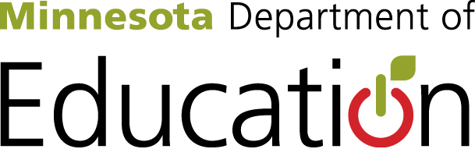
Governor’s PreK – 12 Budget
$604 million in FY18/19 to support students, families and educators
"Education is the Engine to Opportunity and Success."
Meeting the Needs of Students and Schools
- General Education Formula Increase. Increases the General Education Basic Formula by 2 percent in FY2018 and an additional 2 percent in FY2019, a $370 million increase. This will increase the per pupil formula by $121, from $6067 to $6,188 in FY2018 and by an additional $124 to $6,312 in FY2019.
- Special Education Increase. Increases state special education spending by $40 million in the FY2018/2019 biennium. This will reduce the statewide special education cross subsidy by about $20 million, and allow school districts and charter schools to better serve the 133,678 children and youth who receive special education services.
- Debt Service Equalization (Tax bill) Increases the state share of school debt service revenue a total of $20 million for FY2018/2019. Debt service equalization aid helps ensure that school districts regardless of property wealth, can provide adequate facilities for their students. This will increase the number of school districts receiving debt service aid from 40 to 61, and increase the amount of aid for 38 of the 40 districts.
- American Indian Tribal Contract Aid. $4.4 million to make permanent the funding increases to American Indian Tribal Contract aid made in FY16. Without these funds 759 students in 4 Bureau of Indian Education schools will see a 45 percent decrease in state funding.
Investing in Our Earliest Learners
- Voluntary Prekindergarten. Increases funding for the voluntary prekindergarten program by $74 million over the biennium to serve an additional 6,000 students. The governor’s proposal would ensure that more students will be able to enter the program every year.
- Help Me Grow. $3 million over the biennium to expand the current Help Me Grow system to develop a comprehensive statewide, coordinated system of early identification, referral and follow-up for up to 630,000 children prenatal to age 8 and their families.
- Early Learning Scholarship Expansion. Increases children’s access to high quality early care and education programs by expanding access to children ages zero to five.

Community Supports
- Education Partnerships and Transformation Zones. Emphasizes local collaboration and solutions focused on academic achievement and youth development by increasing funding for the Minnesota’s Education Partnership Program and Transformation Zones. Combined, the Northside Achievement Zone, St. Paul Promise Neighborhood, Jones Family Foundation, Independent School District 742 and the Northfield Healthy Community Initiative currently serve over 24,000 children. $1 million over the biennium will allow these entities to continue to support and increase the number of children and families served.
- Full Service Community Schools. Provides $2 million over the biennium to order to reach more children and improve the quality and outcomes of the services provided. There are currently 13 full service community schools. This funding could allow more schools into the program.
Supporting Educators
- Student Support Staff. Addresses shortages of student support staff by providing $4 million in grants to schools to hire more student support services personnel. Last year’s funding allowed schools to hire 77 additional staff. The proposed funding could allow schools to add up to 30 more new staff.
- Online IEP Funding. $1.4 million over the biennium to create a state online special education documentation system. This voluntary system will create a streamlined system and make it easier for teachers to complete required paperwork.
- Pension Relief. Improves the Teacher Retirement Association (TRA) and St. Paul Teachers Retirement Fund Association (SPTRFA) funding status. TRA and SPTRFA serve over 188,000 active and retired preK-12 teachers, administrators, and college and university faculty. Provides $68 million in aid to school districts and charter schools to offset a proposed increase in employer contribution rates for TRA and SPTRFA.
A State Agency that Provides Leadership and Support
- IT and Cybersecurity. $3.5 million over the biennium to provides crucial updates to MDE mainframe applications which were developed in 1974. These applications are used to calculate and distribute $6 billion in state aid and $380 million in federal aid annually to school districts and charter schools.
- An Agency that Supports Schools and Families. Funding to maintain and enhance services to students, families and educators. $10M so that MDE can support schools in meeting their World’s Best Workforce goals, improve educational achievement, and support educators.

