COLA Reduction to 1%
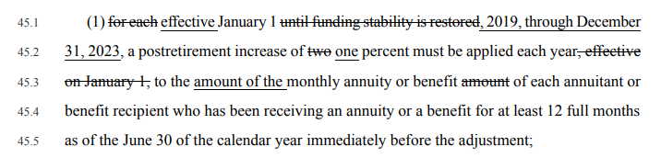
COLA Increases to 1.5%
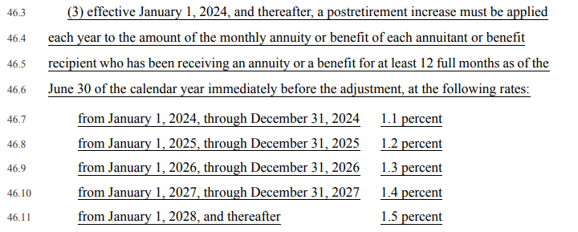

Employee Contribution Increase
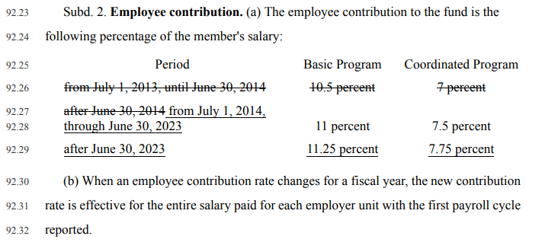

Employer Contributions Increases
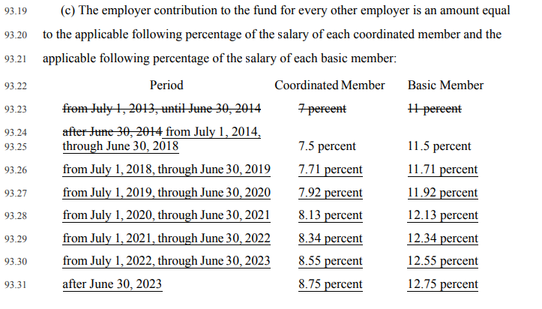

State aid for Employer Portion Increases
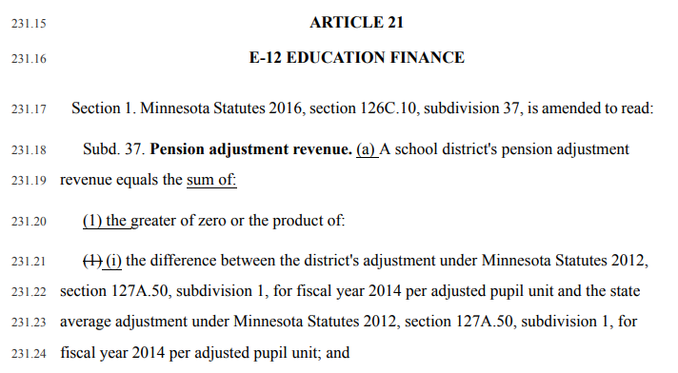

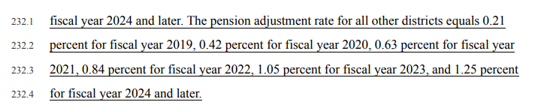

Early Retirement increased penalties
Members of TRA hired after July 1, 1989, who reach the age of 55 and have not reached the age 62/30 years of service threshold need to read 14.18-16.33 in the bill for reductions in retirement prior to the normal retirement age. Then talk with your TRA retirement counselor.

Links to SF 2620
Bill Status
Complete Bill SF 2620

