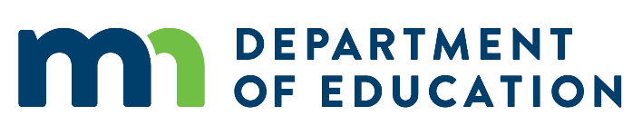

**Quick Guide to Direct and Indirect Costs for USDA School Meals Programs, UFARS Coding and MN State Statute Pertaining to MN School Foodservice**

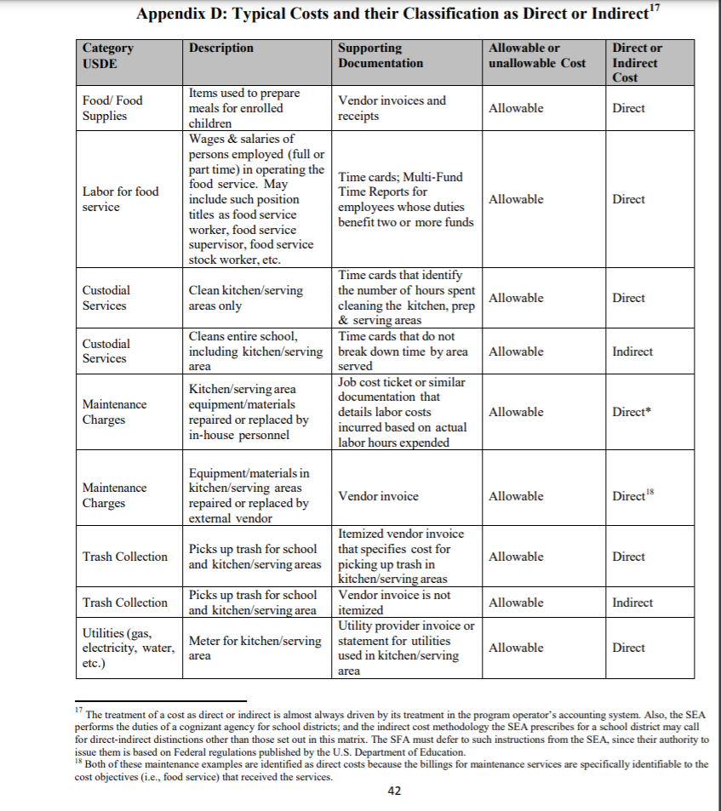

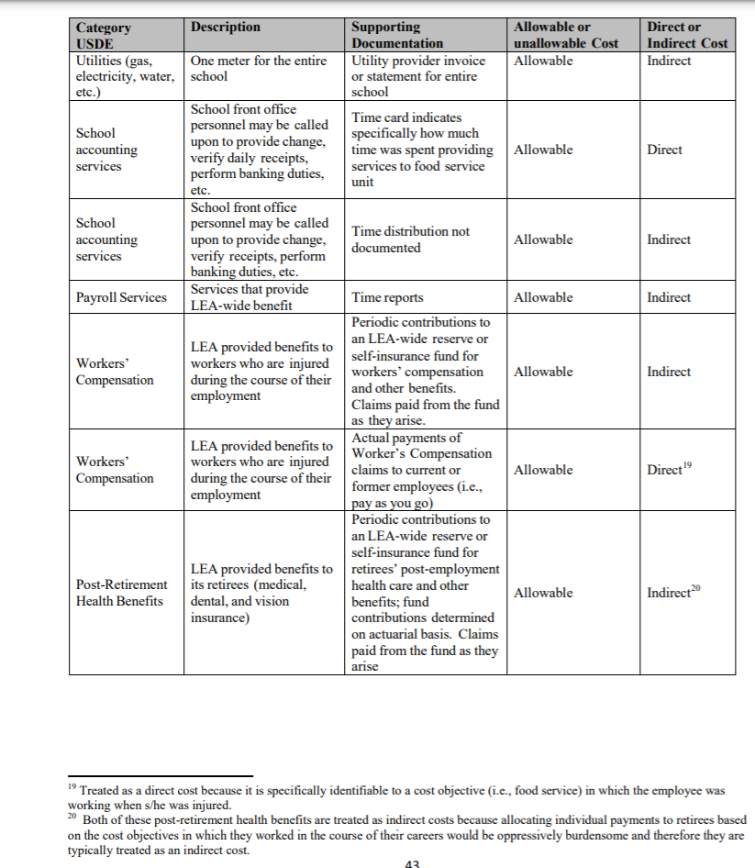

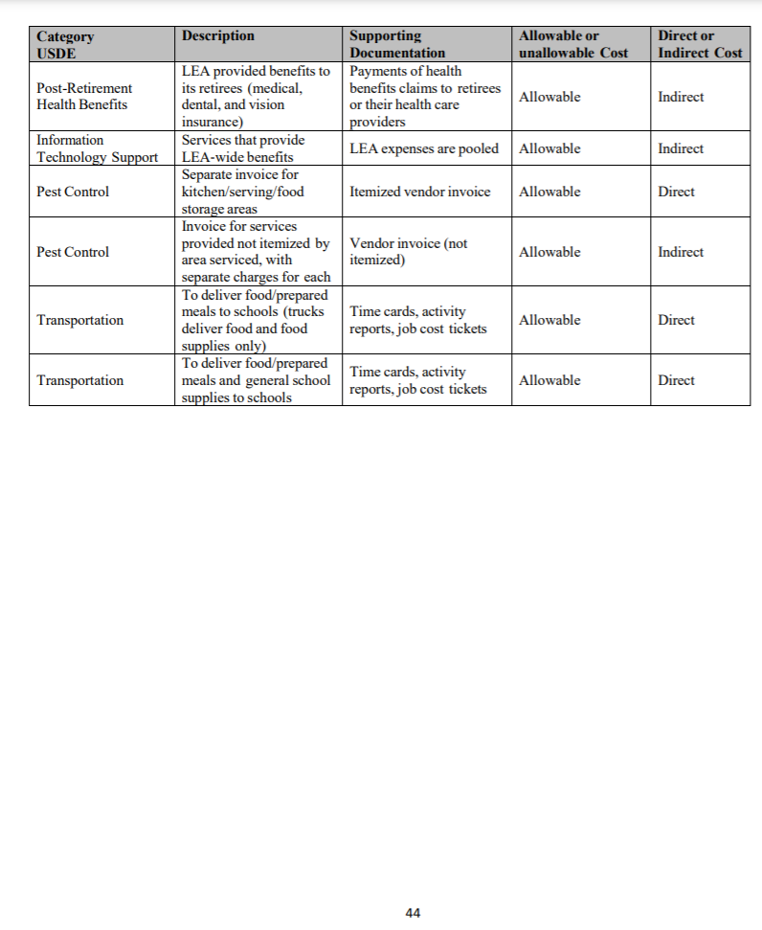

**(Pages 42-44 Excerpted from USDA’s Indirect Cost Guidance Manual:** [**https://www.fns.usda.gov/sites/default/files/cn/SP60-2016a.pdf**](https://www.fns.usda.gov/sites/default/files/cn/SP60-2016a.pdf)**)**

**Relevant UFARS Manual (Chapter 13) Information Pertaining to Fund 02 Reporting**

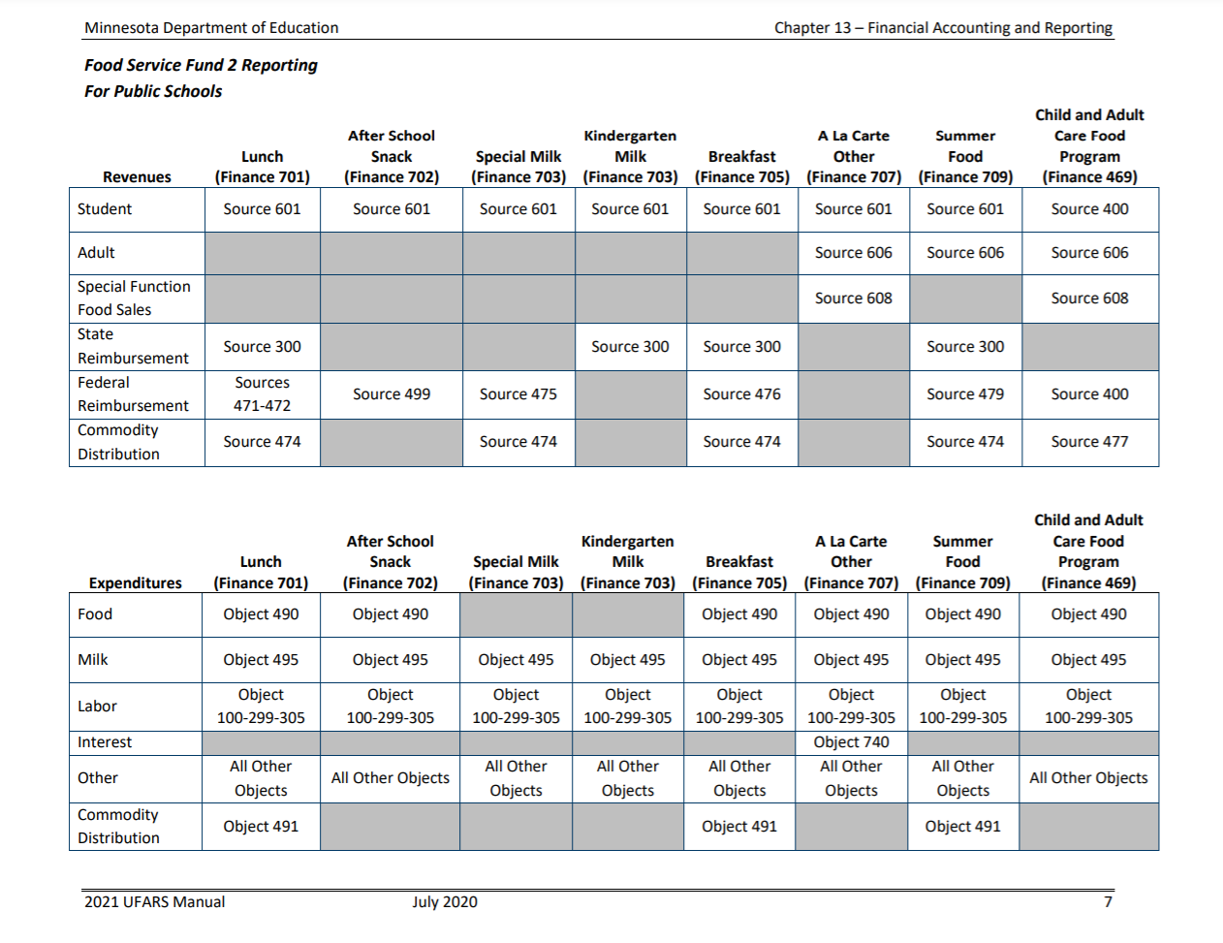

**Direct Distribution**

* **Direct distribution of costs** – This method shall be used when costs can be readily and accurately distributed at the time costs are incurred. **Generally it is the most accurate method, and it should be utilized whenever feasible.** 
  + In those instances where an employee is spending time in different functional areas, which can be documented, the salary should be directly distributed as the expense is incurred or distributed based on a time report.

* + Position descriptions, along with functions actually performed by an individual, should determine the proper salary distribution.
  + Position titles do not determine proper allocation in many instances. For example, if in a small school district the superintendent and/or secretary carry out the daily operations of the food service department, these prorated costs should be directly charged to food service (Program Code 770, rather than Program Code 020).
  + **Also, according to Minnesota Statutes, section 124D.111, subdivision 3, the charges by the superintendent and/or secretary must be at a wage rate not to exceed the statewide average for food service directors as determined by the Minnesota Department of Education (MDE).**
  + **Another example of direct distribution of costs would be the custodial time spent in kitchen clean-up for the food service program.**

**Chargeback Method**

* **Chargeback allocation method** – This method **should be used to distribute the costs that cannot be easily, conveniently and accurately allocated at the same time as the costs are being incurred**.
  + This method allows a school district to allocate costs consisting of several object line items to programs receiving the benefit by utilizing a single chargeback object account.
  + Usually, only the following General Fund programs may distribute costs using the chargeback method to other funds: Program Code 110, Business Support Services; Program Code 810, Operations and Maintenance; and Program Code 930, Employee Benefits.
  + Caution must be used when using the chargeback allocation method involving salaries since many restricted revenue programs require detailed salary information. This includes, but is not limited to, basic skills, learning and development, special education and Title I, II and VI federal programs.
  + A credit entry using the object codes (see chart below) with the appropriate program code creates a contra-expenditure account (credit amount) which must be equal to a corresponding set of debit entries using the same object code. The debit entries result in districts charging the prorated expenditures to the specific program code(s) receiving the benefit of the service. **For each of the chargeback object codes used, debits must equal credits when totaling all funds.**
  + Chargeback allocation method – Only the following UFARS object codes may be used and only within specific UFARS program codes:

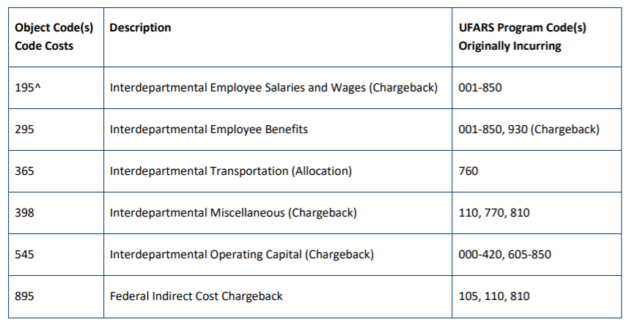

**(Excerpted from the Minnesota Department of Education UFARS Manual:** **https://education.mn.gov/mdeprod/idcplg?IdcService=GET_FILE&dDocName=PROD034267&RevisionSelectionMethod=latestReleased&Rendition=primary)**